Key Factors Influencing the Early Closure of Small Businesses in Kazakhstan

XXXX XXXXX

Course: Global Perspectives and Project Work

Mubaraksha Aldiyar

May 2026

INTRODUCTION

In headily developing economy like Kazakhstan’s, small businesses play a crucial role in economic progress. But the quick success of businesses often turns out to be a failure, most of them close in the early stages due to vague factors. But what are those factors that drive businesses to shut down? Is it a lack of experience, capital, or an inconvenient location of a place? Understanding these factors is essential, not only for entrepreneurs but also for politicians and investors aiming to foster a more sustainable business environment.

Historical Background

Since 1991, when Kazakhstan gained independence, small businesses began to develop rapidly. The collapse of the Union of Soviet Socialist Republics finally allowed people to trade and start their own businesses. Nevertheless, the swift switch to market economy confused amateur entrepreneurs, likewise brought numerous problems in these fields. Over the years obscure legislation, non-supportive institutions, limited access to finance, and run-down business infrastructure created a harsh environment for the upcoming small firms, especially in the first years of operation.
Even though, the government of Kazakhstan has introduced numerous programs assisting the small businesses, they still encounter various obstacles and fail to survive promptly after being set in motion. Poor managerial experience, bureaucratic complexity, economic instability, and external shocks, such as crisis and COVID-19, have further escalated these challenges. Hence, the early closure of small firms still retained a predicament, rising concerns about the viability and long-term contribution of small businesses to national economic development

Problem Statement
In the last few years, the number of small businesses closing in Kazakhstan has risen. They play a vital role in the country’s economy, yet most of them experience an early closure in the first months of being active (Yessengabyl et al., 2022). In accordance to national statistics, small and small-medium businesses make up 39.7% of Kazakhstan’s economy (OECD, 2023). Analytical reports and surveys from organizations like the OECD emphasize the primary reasons businesses in Kazakhstan struggle to survive their early years (OECD, 2023; World Bank, 2021). If not solved, this problem will lead to an economic crisis, a decrease in the country’s GDP, and reducing economic diversification (OECD, 2023). Thus, it is significant to scrutinize this problem, examine the key factors of early closure of businesses in Kazakhstan to develop targeted policies and interventions that maintain their long-time survival

Purpose of the study

The purpose of this study is to investigate the key factors that affect the early closure of small businesses in Kazakhstan. By identifying financial, managerial, and environmental obstacles, this research’s main target is to provide evidence-based insights that can help policymakers, support institutions, and entrepreneurs to improve the survival rate of small businesses and increase their contribution to country’s economy.

Objectives of the study

- To identify and evaluate the key factors that contribute to early closure of small businesses
- To study the effect of the governmental programs and policies in ameliorating the sustainability of small businesses
- To provide recommendations for enhancing the survival and growth of small businesses based on empirical evidence and practice.

Significance of the research

The study is significant since small and medium businesses play a substantial role in Kazakhstan’s economic growth, and diversification of national economy. The understanding of key factors of small businesses’ early closure can help policymakers, government agencies, and financial institutions develop ways to support entrepreneurship and diminish business failure rates.

Scope of the study

This research will include different statistics and factors drawn from studies by economists, business analysts, and government reports, and will provide survey results, and case studies about the factors affecting the early closure of small businesses. The geographical scope will be limited to Kazakhstan, including both urban and rural areas. The temporal scope will include data and trends from previous years, while also considering the newest policies and novel reforms that may affect the early closure of small businesses.

Literature review

The rapidly growing problem of small businesses' early closure has turned into a tremendous problem, deteriorating the state of economic development, employment, and innovation, particularly in countries like Kazakhstan. Small and medium-sized businesses (SMEs) play a crucial role in diversifying the national economy, reducing dependence on natural resources, and fostering regional development. However, despite government support programs, a substantial proportion of small businesses in Kazakhstan cease operations within the first few years of establishment. This literature review will contemplate every renowned factor affecting the early closure of business and evaluate the significance of Covid-19 in entrepreneurship.
Key definitions
Early business closure
Early business closure refers to the termination of a business within the first few years of operation, typically before it reaches organizational stability or long-term viability. This phenomenon is particularly common among new firms that lack established routines and sufficient resources (Organization for Economic Co-operation and Development, 2017, p. 72).

Business failure
Business failure is defined as a situation in which a firm is unable to continue operations due to persistent financial distress, declining performance, or inability to meet its obligations. Importantly, business failure is not synonymous with business closure, as firms may exit the market voluntarily or for strategic reasons (Altman & Hotchkiss, 2006, pp. 5–6).

Liability of newness
The liability of newness describes the heightened risk of failure faced by newly established organizations due to limited experience, lack of legitimacy, undeveloped internal processes, and weak external relationships. These vulnerabilities make young firms more susceptible to early closure (Stinchcombe, 1965, p. 148).

Financial constraints
Financial constraints refer to limitations in a firm’s ability to access internal or external financial resources necessary for sustaining operations and growth. New and small firms are especially affected by financial constraints, which significantly increas the likelihood of early business closure (Carpenter & Petersen, 2002, p. 300).

Experts’ perspective
The early closure of businesses has been a tremendous concern in entrepreneurship and global economy, with scholars identifying a combination of economic, structural, and environmental factors affecting it. Globally, research suggests that young and small enterprises are particularly vulnerable during their first three to five years of operation, a period called “liability of newness” (Stinchcombe, 1965). Limited experience, fragile cash flows, and underdeveloped managerial capabilities significantly increase the probability of early failure (Coad, 2013).
One of the most frequently noted factors leading to early business closure is financial boundaries. Experts argue that limited access to external financing, high interest rates, and weak credit infrastructure restrict firms’ ability to invest, scale, and resist short-term losses (Beck & Demirgüç-Kunt, 2006). Start-ups and new projects often rely strongly on personal savings, credits, and informal borrowing, which limits stability during periods of declining revenue. Studies across developing economies indicate that financial instability is a leading predictor of firm exit, especially in gradually changing macroeconomic environments (Ayyagari et al., 2011).
Another crucial factor affecting the early closure is managerial incompetence. Weak market analysis, corruption, and ignorance of business details often play a substantial role in businesses’ devastation, leading to inevitable exit (Gaskill et al., 1993). Inexperienced entrepreneurs may underestimate operational costs, overestimate demand, or fail to adapt their businesses to changing consumer preferences. Global evidence suggests that firms led by owners with prior sphere experience and high level of human capital demonstrate significantly higher survival rates (Ucbasaran et al., 2010).
Market competition and globalization also play a substantial role in shaping business survival. Increased market saturation, the entry of multinational corporations, and the expansion of online retail platforms have intensified competition worldwide (Audretsch, 1995). Small and medium-sized businesses frequently have problems competing with larger firms that benefit from their scales, advanced technology, and stronger brand recognition. As a result, many local businesses exit the market within a short period of time after entry.
The Covid-19 pandemic dramatically accelerated business closures across the globe. Experts agree that lockdown, supply chain disruptions, and sudden declines in consumer demand affected small firms in different ways (Bartik et al., 2020). Unlike large corporations, SMEs generally lacked finances to withstand prolonged revenue losses. Research indicates that sectors such as hospitality, retail, tourism, and personal services experienced the highest rates of permanent closure during the pandemic (Organization for Economic Co-operation and Development, 2021).
Furthermore, scholars highlight that the pandemic escalated structural weaknesses that already existed before Covid-19. Firms with low levels of digitalization and limited online presence were less able to pivot toward remote operations (Kraus et al., 2020). In contrast, businesses that rapidly adopted digital technologies and flexible operating strategies demonstrated greater resistance and survival.
From a policy perspective, experts note that government support mechanisms significantly influenced business survival during Covid-19. Subsidies, low taxes, emergency loans, and rent discounts programs helped mitigate closure risks in many countries; however, access to such support was often languid (Didier et al., 2021). In developing economies, including Kazakhstan, bureaucratic barriers, information gaps, and delayed implementation limited the effectiveness of government’s assistance, resulting in many businesses’ inability to recover from such losses.
In the contemporary world, technology plays a huge role in the development of various industries, especially businesses. Novel technologies such as artificial intelligence (AI), automatic systems, robots, and data analytics help to do all meticulous and scrupulous tasks much faster, being conducive to steady business growth. Rather than merely assisting with daily tasks, these technologies alter the model of business, cost structures, and competitive dynamics. As a result, inventions have become a crucial determinant of business’ long run.
Recent research highlights that nowadays technological advancement is an obligatory rather than an option. Digital transformation is a comprehensive organizational change driven by digital technologies that alters value creation processes, operational efficiency, and customer engagement (Verhoef et al.,2021). Firms that successfully adapt to new changes demonstrate greater responsibility and productivity in comparison to other businesses. Digitally mature firms were more flexible during economic crises, particularly during Covid-19 epidemy, as they were able to turn toward online operations and remote work system.
Artificial intelligence has emerged as an assisting tool in current business environments. AI powered analytics improve demand forecasting, inventory management, fraud detection, and predicting customers’ preferences. Dwivedi et al. (2021) noted that AI enhances data-based decision-making processes by abating uncertainty and improving accuracy of predictions, thereby strengthening firms’ strategic positioning. Moreover, implementation of AI reduces time spent on drudgery, repetitive and labor-intensive tasks. It allows enterprises to reduce costs and relocate human source toward higher-value activities
However, the dissemination of AI has established a new problem in the face of the asymmetrical competitive advantages. While large companies usually have more possessions they could spend on implementing new technologies, small firms mostly lack digital incorporation due to poor state finances. According to The Organization of Economic Co-operation and Development, SMEs face constraints such as high implementation costs, limited technology knowledge, and limited access to advanced systems and technological infrastructure. These boundaries increase the vulnerability of smaller companies to market exit.
Kazakhstani context
Before the Covid-19 epidemics, Kazakhstan’s business environment was gradually digitalizing alongside having structural vulnerabilities. The economy was highly dependent on natural resources, especially oil export, which made SMEs sensitive to external shocks such crises and lockdowns. Although national programs such as Digital Kazakhstan aimed to accelerate the digitalization and adoption of new technologies, its effect was mildly seen among SMEs. Prior to 2019, the digitalization index was increasing steadily but at a relatively moderate pace. Large companies effectively implemented new automatic systems, especially in the economy sphere. Whereas small firms experienced the paucity of new infrastructure; they were limited in techno-sphere due to high costs of systems, insufficient digital skills, and restricted access to high-quality infrastructure.
The Covid-19 pandemic was a huge external shock for Kazakhstan, leaving the country in tremendous crisis. Lockdowns, immobility, and temporary closure of enterprises led to a change in business model in Kazakhstan. Sectors such as hospitality, retail trade, and transportation were particularly affected. Firms with high-level digitalization stood strong and demonstrated greater resilience. In contrast, businesses lacking automated systems experienced sharp declines in revenue, hitting the rock bottom. It resulted in many firms’ closures. The pandemic precipitated online commerce growth, contactless payments, and online service delivery. However, this shift has created a huge gap between technologically progressive and lagging businesses.
In the post pandemic period, Kazakhstan’s business ecosystem was more about digital renovation and flexibility. Consumer behavior has shifted toward online shopping, creating demand for e-commerce and online services. Firms that invested in digital development during the Covid-19 pandemic have rigidly maintained their places in the country’s economy. Nevertheless, structural problems still persist. Inflation, currency instability, and geopolitical uncertainty in the Eurasia continue to affect business policy in Kazakhstan. In this environment, technological efficiency and cost optimization have become even more important than they were before. Businesses that failed in emergency digitalization during the pandemic face competitive pressure and higher risks of market leave.
This literature review has examined the key factors affecting the early closure of businesses, with particular emphasis on digitalization and external shocks. Global research indicates that financial fragility, managerial incompetence, institutional conditions, and digital cognition collectively shape firm survival outcomes.
In the Kazakhstani context, the transition from gradual pre-pandemic digitalization to rapid technological adaptation during the Covid-19 epidemic highlights the growing importance of new technologies and gadgets nowadays. Overall, the evidence suggests that digital knowledge has become a central determinant of sustainable business survival in both global and local environments.

Methodology
Research design
For answering this research question, mixed methods of research was chosen. “Mixed methods research is the type of research in which a researcher combines elements of qualitative and quantitative research approaches for the broad purposes of breadth and depth of understanding and corroboration.” (Rachel Banawa, 2025). This design is applicable to our study, since it gathers opinions of experts regarding operational realities and information about societal and economic perception held by the younger generation. The phenomenon of business closure is a highly complicated process that is influenced by numerous factors, such as economic indicators(quantitative) and individual entrepreneurial experiences(qualitative). By using this approach, the study will capture vast trend across the Kazakhstani markets while also profoundly scrutinizing specific challenges faced by local enterprises.
This choice was based on the idea of triangulation. According to Tashakkori and Teddlie (2010), "the use of multiple methods leads to a more robust and comprehensive understanding of the research problem, as it offsets the inherent biases and weaknesses of a single-method approach." Starting with a quantitative phase, we collect broad information, and following with a qualitative approach, we get to know obscure factors and then scrutinize them.
Research instruments
To ensure profound data analysis, two distinct research instruments will be used.
Quantitative instrument(Online survey): firstly, online survey will be distributed amidst different platforms to ensure a high participation rate. Survey will utilize 5-point Likert scale, using ‘strongly disagree’, ‘disagree’, ‘neutral’, ‘agree’, ‘strongly agree’, so the participants can show the extent of their agreement with the question. According to DeVellis and Thorpe (2021), structured scales are essential for measuring concealed constructs like "perceived bureaucratic burden" or "financial instability." The survey will focus on dividing failure factors into 2 groups: external (high interest rates, tax legislation, etc.) and internal (poor management, lack of marketing strategy). This division allows the identification of significant patterns across regions of Kazakhstan.
Qualitative instrument(interview): following the survey, 2-3 in-depth interviews will be conducted. According to Ritchie and Lewis (2003), "semi-structured interviews provide a unique opportunity to explore the personal experiences, motivations, and hidden social barriers - such as administrative pressure or 'blat' (social networking)-that are often excluded from formal statistics." The implementation of qualitative instruments to the research is crucial to explore the ‘human element’ of business failure in Kazakhstan. The interview guide will start with brief close-ended questions to get to know the credibility of the interviewee and give them the opportunity to open; following, open-ended questions will be asked to analyze specific sides of the problem and the effectiveness of government subsidies.
Research participants and Site
The study uses a dual sampling strategy to capture both broad answers and expert insights. The site used to conduct the study is Nazarbayev Intellectual School (NIS) of Chemistry and Biology in Karaganda.
For the quantitative part of the research, simple random sampling will be used to select approximately 100 students from the 11th grade parallel in NIS Karaganda. According to Creswell (2014), random sampling ensures that every individual in population has an equal chance of being selected, which reduces bias and generalizes the results to the wider student body. This group is chosen because it was taught the basics of business and economy, thus being able to give relevant answers.
For the qualitative part, convenience sampling will be used to select 2-3 school teachers and experienced businessmen who are researcher’s acquaintances. Saumure and Given (2008) define convenience sampling as a technique where participants are selected based on their availability to the researcher. This sampling method is highly effective in gaining high-level, ‘insider’ information from people who possess profound knowledge on the presented topic. Experts check the relevance of the theoretical views provided by the students.
Data analysis and integration
The analysis will be conducted in 2 stages and, as said before, the analysis will follow a triangulation model. Initially, quantitative data will be processed using statistics (mean, standard deviation, frequency) to rank factors by their significance. This will show the most common challenges faced by businesses in Kazakhstan.
Subsequently, Qualitative data will undergo thematic analysis. According to Braun and Clarke (2021), thematic analysis is a method used to identify, analyze, and report patterns within data. In terms of study, it will be used to concretize some factors provided by survey takers; for example, if student identifies ‘taxes’ as a problem, the experts can explain the specific complexities that make the problem so huge. It provides a very sophisticated analysis that reveals the whole mechanism of business failure problem.
Ethical considerations
Conducting research, all ethical considerations will be abided by. In accordance with the British Educational Research Association (BERA, 2018), all participants, both students and experts, will be fully informed of the research purpose. Participation is entirely volunteer and wasn’t obliged. Written consent will be obtained from the business experts. Additionally, to protect the reputation of specialists, privacy will be respected and all participants will stay anonymous.
Results
Introduction
The purpose of this chapter is to present and analyze the data collected during the research process. This research used mixed-methods approach to identify factors of early closure of business. The data was derived from two primary sources:
Quantitative data: A survey conducted among 11th-grade students to get to know their opinions about boundaries and problems faced by enterprises in Kazakhstan which directly or indirectly contribute to their cessation of operations.
Qualitative data: An interview with an entrepreneur to provide real-life insights into different aspects of running a business.

Quantitative results

Figure – Question 1
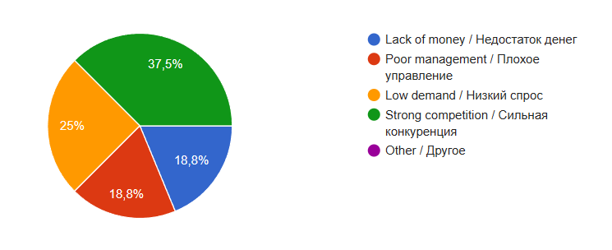

Figure 2 – Question 2
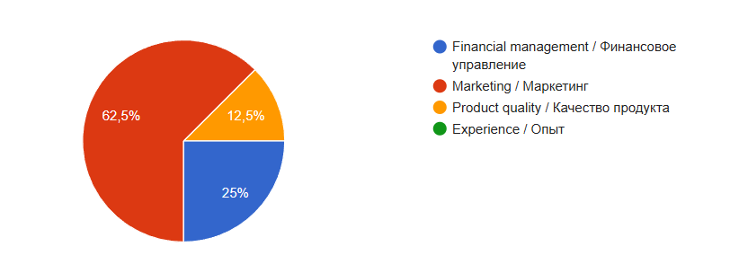 As shown in the pie chart, 62.5% of participants believe that marketing is instrumental in business’ success. Percentage of people who see financial management as the main reason for business’ prosperity constituted 25%. Half the figure of financial management, 12.5% of attendees believe that product quality matters more than other factors. This implies that young people prioritize visibility and brand promotion over technical aspects of entrepreneurship.

Figure 3 – Question 3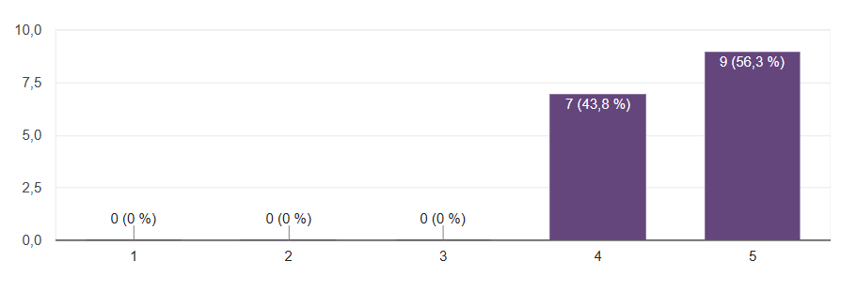 The survey examined how students perceive the role of financial management in the survival of a company. Respondents were asked to rate the importance of financial management on a scale of 1 to 5.
As shown in figure 3, the results were extremely positive. 56,3% of attendees gave the highest possible score of 5, while the remaining 43.8% rated it a 4. The average score was approximately 4,6. This indicates the high level of awareness among 11th grade students that survival of business heavily hinges on managerial abilities of entrepreneurs and managers.

Figure 4 – Question 4
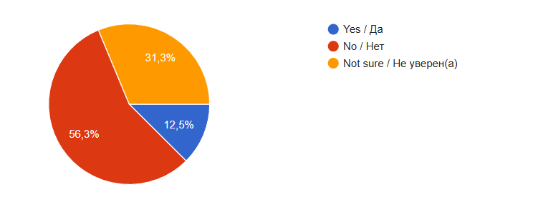
Figure 4 depicts the level of awareness amidst survey takers regarding government programs that support SMEs in Kazakhstan. Figure of people who voted ‘no’ dwarfed all other categories, meaning that a majority of respondents were not aware of any business supporting government programs. Meanwhile, 31,3% of respondents were unsure, and only 12,5% confirmed that they were aware of government support programs. This finding shows a potential gap in communication between people and the government.

Figure 5 – Question 5
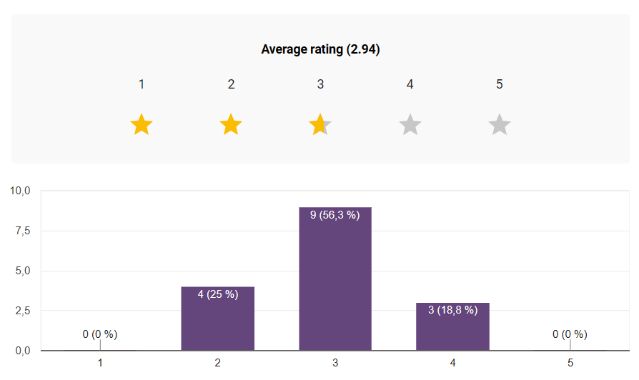
The overall rating of the effectiveness of business support programs showed that most respondents rated it neutrally, the figure of ‘neutral’ voters being 56,3%. 25% of voters said that entrepreneurial support is low effective, while 18,8% of attendees said that programs are mostly effective. This illustrates an inauspicious attitude towards government led entrepreneurial programs among the youth

Figure 6 – Question 6
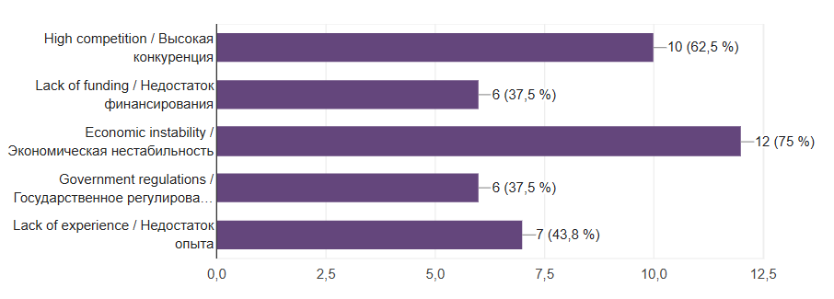
The final question aimed to identify problems faced specifically by Kazakhstani enterprises. Respondents were allowed to select multiple answers.
As demonstrated in figure 6, the responses stress three dominant challenges:
- Economic instability: 75% of people chose it as one of the boundaries for entrepreneurs in Kazakhstan. It reflects concerns regarding currency fluctuations and general market unpredictability.
- High competition: Standing at 62,5%, this factor confirms that local market saturation is a huge concern for new businesses.
- Lack of experience: cited by 43,8% of voters, it shows that enterprises may face problems during their first years due to lack of managerial experience and knowledge

Qualitative results
The qualitative results section presents the findings from two interviews conducted with experts in the business sphere. The goal was to identify and analyze internal and external factors contributing to the closure of business in Kazakhstan. Data was categorized into four main themes.
Theme 1: Entrepreneur’s personal traits
Both interviewees mentioned that the success of business is heavily dependent on entrepreneurs’ personal traits and planning abilities.
Interviewee 2 highlighted that personal traits like impatience (0:08) and a lack of stress resistance (0:41) are factors leading to failure. Interviewee 1 noted that without a proper system, a lack of profit becomes inevitable. The main challenge is to forecast demand. Specifically, interviewee 2 mentioned that a paucity of a proper marketing strategy (3:27) led to the closure of their own cosmetics business.
Theme 2: Financial literacy and management
Financial management was identified as one of the most crucial factors assisting businesses in staying competitive. Interviewee 2 explained that entrepreneurs must manage their turnover: “You need to understand what share you are ready to allocate for promotion, and what part you will take for yourself” (0:48). Interviewee 1 argued that “With proper financial management, a business remains flexible. You can identify the "bottom" and see additional levers for growth”. Both experts linked poor management to a lack of funds to continue operations, leading to a low flow of customers and negative revenue.
Theme 3: Competition
External factors play an important role in business life. Demand was cited as the primary driver for starting a business. Interviewee 2 noted that while demand for essential goods (e.g. bread, milk) is stable, other sectors are highly sensitive to the country's economic situation. Interviewees viewed competition from 2 angles; while the former warned of price wars and dumping by established players, the latter suggested that competition can be beneficial as it makes businessmen develop new innovations (2:17) to remain unique.
Theme 4: Challenges in Kazakhstan
The interviews revealed several challernges that are unique to Kazakhstan. Both experts identified the rise of large marketplaces as a threat to retailers, leading to a downfall of small businesses. Additionally, interviewee 1 provided challenges such as low population density and vast distances between cities. Interviewee 2 concluded by mentioning the administrative burden; specifically, taxes this year are high, which hinders businesses’ early-stage survival.
Integration of findings and literature review
The research findings align with the theory provided in literature review, specifically regarding the challenges faced by enterprises.
The survey results, where participants identified lack of experience as a factor contributing to the early closure, support Stinchcombe’s (1965) liability of newness theory. Furthermore, Interviewee 2, whose cosmetics business failed due to poorly organized marketing strategy, confirmed that underdeveloped internal processes (Ucbasaran et al., 2010) are a primary cause of early closure.
The high importance assigned to financial management in the survey (roughly 4.6/5) matches the arguments of Carpenter and Petersen (2002) about financial limitations. The interviews added more to it, describing how poor budgeting conduces to the fragile cash flows mentioned by Coad (2013). Additionally, participants' opinion regarding the importance of economic instability as a contributing factor in both the survey and interviews reflects the macroeconomic sensitivity discussed by Ayyagari et al. (2011).
The literature review noted that market saturation and online platforms increase competition (Audretsch, 1995). This is confirmed by 62,5% of survey respondents, who voted for competition as one of the biggest challenges in Kazakhstani business environment, and both interviewees. Finally, the low effectiveness rating of government support (2.94/5) in the survey shows barriers and information gaps in Kazakhstan previously identified by Didier et al. (2021).

Conclusion
This study discovered multiple internal and external vulnerabilities contributing to the early closure of business in Kazakhstan. The lack of managers who assist owners with administrative issues is a primary cause of failure; many owners managed all operations, from logistics to marketing, which led to collapse when they faced burnout or lacked assistance from outside. Furthermore, many startups fail by following popular trends without an analysis. Businesses that closed within 18 months tend to skipped market and competitive analyzes, leading them into oversaturated markets. Additionally, businesses that were reluctant of integrating digital services had a significantly higher failure rate. Nowadays, businesses are obliged to have online assets and work through online connections.
To evaluate the effect of governmental programs on businesses, the research analyzed the relationship between governmental support and real market. Despite government support, many entrepreneurs face a gap between policy and practice. Experts cited that a complex tax system and unpredictable changes of law are the main constraints for long-term survival. For businesses dependent on imports, tenge instability acts as a financial burden. This currency instability led to the closure of many firms, as their revenue was not enough to cover the increasing cost of rent and products.
Finally, based on empirical evidence, the findings suggest enterprises to implement structural and strategic changes. Mitigating these vulnerabilities requires focusing on digital integration and market research. The local business ecosystem can foster a more sustainable environment for prosperity by addressing the gap between policy and practice,

Limitations
The main problem with research and data gathering is inadequate sample size. Although the methodology aimed to gather opinions of over 100-150 participants, the final quantitative data was gathered from a smaller group of 50 participants. Consequently, the results should be viewed as a low scaled insight rather than a distinct representation of the entire Kazakhstani market. It affected validity of the study.

Furthermore, a significant bias may appear in the qualitative data analysis section, since the expert interviews were conducted with individuals who are acquaintances of the researcher. While businessmen provided high-level professional analysis, their relationship with the interviewer could have influenced their answers. It affected the reliability of the study.
Lastly, because the study focused heavily on participants within a specific professional and social circle, the findings may lack the diversity compared to data gauged in more broad research environments. Acknowledging these constraints is vital for reliability of the current conclusions. It affected the generalization of the study
Implication
The findings of this study suggest that the failure of business in Kazakhstan is not only a matter of capital, but also a consequence of a gap in entrepreneurial education. Consequently, policy level interventions are necessary to provide small business owners with proper education in risk assessment and digital adaptation. These results also imply that establishing strong mentorship bond between professionals and business owners is crucial to mitigate the ‘isolation’ factor identified in the qualitative research. For academic community, this study is essential, since it stresses the importance of analyzing regional shifts rather than outdated data. Ultimately, mitigating these vulnerabilities will foster a more sustainable ecosystem for business prosperity.

Further research

While conducting this research, new opportunities for further research have been discovered. Since this research was primarily exploratory and limited in its geographical and demographic scope, a more profound analysis would be beneficial. Tracking currently active firms and startups would allow researchers to identify the specific point where the business’ failure becomes inevitable and irreversible.

Furthermore, scope of quantitative data analysis could be expanded in order to achieve more precise analysis in distinct areas; for example, taking rural area into account would make data analysis deeper, since the data can be compared to other urban areas and cities, such as Almaty and Astana. Factors affecting business closure in different areas may vary, that is why it is important to conduct broad surveys and experiments that target all demographic and geographic groups.

Finally, it would be valuable to conduct a comparative analysis of government support programs versus private sector initiatives. It would be beneficial in determining which type of intervention is more influential and has higher success rate in preventing business closure – direct financial help or skilled mentorship.

